

School of mechanical and manufacturing engineering

Design of Impact Resistant Composite Window Covering for Emergency Cyclone Protection

Name: Hengcheng Zhang

Student ID: z5130844

# Executive Summary

Due to the higher stiffness, strength with a lower weight and better energy absorbing capability, composite material are widely used in modern industry. The aim of the project is to design a reliable composite window protection board to replace traditional wooden ones. The function of this composite board is to protect window from debris during cyclones. As instructed in Australia standard and design guidelines for Queensland public cyclone shelters. This kind of structures must be able to withstand impact tests with a certain load. These impact tests could be expensive and very time consuming. To speed up and simplify the design process, a numerical way was taken into usage with the help of ANSYS Workbench.

The first step to construct a valid simulation model, one set of high velocity impact test results was found. [1] The prototype of our model was built according to the experiment settings, such as dimensions, boundary conditions and material properties. The test data was used to validate the simulation result.

In order to construct a more accurate composite material structure, the ANSYS Composite Prep Post (ACP) package was applied. The ACP package is an add-in to ANSYS Workbench to deal with the complex definitions of composite materials with numerous layers, materials, orientations and thicknesses. This package is integrated with the standard analysis features. [9] The constructing process was demonstrated in chapter 4. By constructing the layers and materials in ACP, the mesh method in thickness direction was defined simultaneously. The face sizing of mesh was added on the original surface body. Mapped quadrangles were used to build the structured mesh. Structured mesh has the advantage of better accuracy and less calculation time consuming. Thus the whole solid model is completed. Smaller size mesh elements are allocated around the impact area for refinement. An H-convergence method were applied to make sure the reliability and accuracy of these meshing method.

The validated prototype model was modified by the requirement of a dimension of window. The impact load was set as instructed in the design guideline. A sensitive analysis is performed to investigate the

Contents

1. Introduction 3

2. Project Description 3

3. Mathematical Model and Assumptions 4

4. Mesh and Refinement 5

4.1 Mesh Method 5

4.2 Mesh Refinement 6

5. Results 7

6. Validation 8

7. Window protection board design 8

7.1 Model of Window Protection Board 9

7.2 Mesh and refinement 10

7.3 Results and Discussion 11

8. Conclusion 12

Reference 13

# 1. Introduction

Australia suffers from some extreme whether every year. Cyclones and storms could be severe and extraordinarily harmful. One of the dangers in heavy storm and typhoon is that debris may smash through windows. In order to prevent this and to protect people from harm, standards and design guidelines are published. For example Australia standard of structural design actions (AS 1170) [7] and design guidelines for public cyclone shelters [5]. The aim of this project is to design a composite board to protect window glasses in this circumstance. Wooden boards are commonly used, but composite boards could be stronger and lighter.

There are different types of composite materials, and composite sandwich materials are utilized in this inspection. This kind structure is normally composed of three layers, two face sheets and a core. The two face sheets are adhesively bonded to the core, thus one skin acts in compression as the other skin acts under tension and the core resists the shear load. This provides high stiffness, strength to weight ratio and energy absorbing capability to the structure. Nowadays, Composite laminates and sandwich structures are widely used in civil, marine, transport and even military industries.

The most direct way to understand properties of composite structures is experiment. Intensive researches have been conduct. There are two kinds of impact test are most commonly taken: low velocity impact test and high velocity impact test. Low velocity impact is usually a heavy object, more than 1 kilogram free-fall dropping from a certain height. [8] The impact velocity is lower than 10 m/s in common. The high velocity impact on the other hand is taking low mass object to impact the test material in high velocity. As is shown in figure 1, the projectile is shot out by a gas gun. The velocity of the projectile is measured before and after the target material. The residual velocity of the projectile after the target is the key results to be studied.

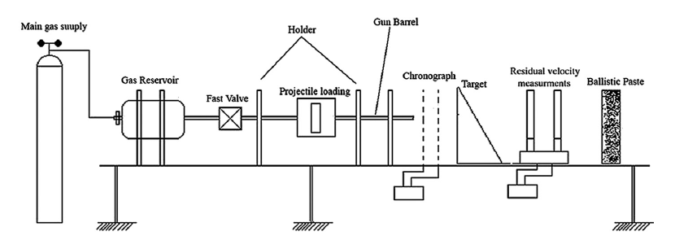

*Figure 1: High Velocity Impact Test*

This designing process is trying to find some suitable material and structures which has been tested by other researchers. According to the Australia standard, high velocity impact test data is more suitable for this project, such as [1] and [2]. Their experiment structures are utilized to set up a numerical model and the test data is used to validate the model. ACP and Explicit Dynamic Modules are used in this project to run the simulation. ACP is a unique module in ANSYS, used especially for composite structures, while Explicit Dynamic module is used to run the dynamic simulation process.

Once this model is validated, it is modified in dimensions to suit for the window protection usage. Then materials and their thicknesses are adjusted to adapt to the standards and design guidelines. A sensitive analysis is performed to instruct how to design this product. The chosen indicators are: energy absorbing effectiveness, cost and the damaging situation. This model could not be validated by test data.

# 2. Project Description

This project aims to design a composite board to protect windows from cyclone debris impacting. Under Australian law, this kind of design must comply with Australian Standards AS 1170.2,2011, Structural design actions part 2: Wind actions. As stated in 2.5.8, impact loading from windborne debris, there are two load need to be tested:

1. A timber test member of 4 kg mass, of a density of at least 600 kg/m3, with a nominal cross-section of 100 mm x 50 mm impacting end on at 0.4 VR for the horizontal component of the trajectory, and 0.1 VR for the vertical component of the trajectory;
2. A spherical steel ball 8 mm in diameter (approximately 2 grams mass) impacting at 0.4 VR for the horizontal component of the trajectory, and 0.3 VR for the vertical component of the trajectory.

Some more strict design guidelines are found, such as Design guidelines for Queensland public cyclone shelters [6]. It also instructs two impact loads:

1. A 100 mm * 50 mm piece of timber of 4 kg impacting end-on at 0.4 * V10,000 for horizontal trajectories and 0.1* V10,000 for vertical trajectories;
2. Five spherical steel balls of 2 grams mass (8 mm diameter) impacting at 0.4 * V10, 000 for horizontal trajectories and 0.3 * V10, 000 for vertical trajectories.

VR and V10, 000 are both the reginal wind speed. V10, 000 means it’s the 1 in 10,000 years’ probability based criterion. For Queensland’s tropical cyclone region, V10, 000 is 306 km/hr, which equals to 85 m/s. VR in AS 1170 is 81 m/s. To ensure the safety of this design, the design guideline for Queensland public cyclone shelters criteria is used in this project. Due to the limit of time, only load b is simulated.

One set of high velocity impact experiment structures and data which is similar to these criteria are chosen to be simulated and built this numerical model. The experiment is taken by Shirley K Castillo [1]. The tested composite material board is made of 3 layers, two E-glass/polyester woven laminate face-sheets and one PVC foam core. The thickness of face-sheet is 3 mm and the thickness of core is 30mm. The dimension of the plate is 160*160 mm2. The sandwich composite board was impacted by a steel spherical projectile, which is 1.7 g in weight and 7.5 mm in diameter. The impact velocity is from 80 to 772 m/s. The PVC foam is isotropic, and its density is 100 kg/m3. The mechanical properties of E-glass materials are listed in table 1.

Table 1: Mechanical Properties of E-glass laminate

|  |  |
| --- | --- |
| Density | Ρ = 1800 |
| Young's modulus (GPa) | E1 = E2 = 10.1 |
| Poisson ratio | ν12 = 0.16 |
| In-plane shear modulus(GPa) | G12 = 3.1 |
| Interlaminar shear modulus(GPa) | G13 = G23 = 3.1 |
| Tensile Strength(MPa) | XT = YT =367 |
| Compressive strength(MPa) | XC = YC =304 |
| In-plane shear strength(MPa) | S12 = 120 |
| Interlaminar shear strength (MPa) | S13 =  S23 = 34.3 |

This experiment is taken use of to make sure that the simulation approach is acceptable. Then this model could be modified and applied to design any other size of composite window protection board. In this project, a balcony glass door is used as the protection target. It is 2 m in height and 1 m width. Load b from the guideline above is acted on the new model to find out the ballistic limit. By adjusting the thickness of face sheet and core, the lightest and cheapest structure could be found.

# 3. Mathematical Model and Assumptions

In order to simulate the experiment in ANSYS, a few assumptions and simplifications need to be made.

The first thing to consider about is the boundary conditions. The tested plate was fixed on the four edges by a holder, which has a 160*160 mm hole in the centre of it. It is simplified as a 160*160 mm plate with fixed boundary condition on the four edges of all three layers.

As the geometry and force in this case are all symmetric, this model could be further simplified as one quarter of it. While applying the symmetry scheme in this model, the two separation plane are the x-z plane and y-z plane. There should have no displacement normal to the symmetry plane and no rotation parallel to plane too. The boundary conditions are shown in the following figure and table.

The projectile is allocated with an initial condition of velocity, which is set according to the experiment inlet velocity. The projectile is also symmetrised, so the boundary conditions on the symmetry plane are applied to it too.

*Table 1: Boundary Condition and Force*

|  |  |
| --- | --- |
| **Label** | **Boundary Condition** |
| A | Fixed support |
| B | Symmetry Region |
| C | Symmetry Region |

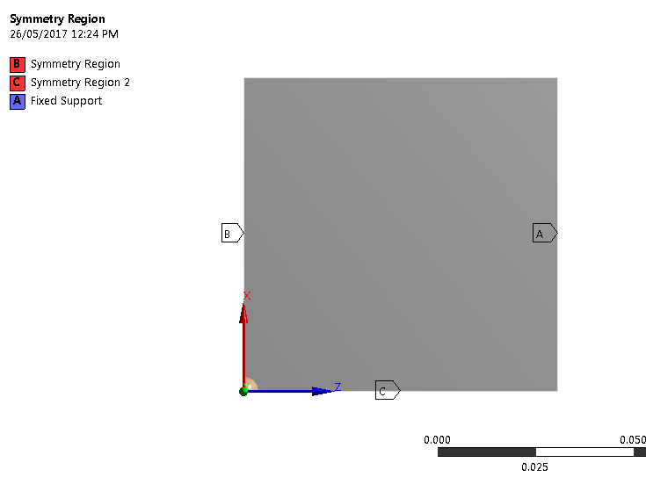

*Figure 2: Simplified Geometry and Boundary Conditions*

The face-sheet material is given by the experiment data, but there is no fibre orientation information. The alignment of fibres in composite structures could result in different strength properties in different directions. [Armin Kanani](https://www.youtube.com/channel/UCuTxSx5iJ4I23xvT1b-hKKA) suggested a stacking sequence for a 6 layer glass fibre material. It is used in the simulation of the two face-sheets. The direction of each ply of face-sheets and core is listed in table 2.

*Table 2: Stacking sequences for E-glass/ polyester woven face-sheets*

|  |  |
| --- | --- |
| Front Face-sheet | [0°/90°/0°/90°/45°/-45°] |
| Core | [0°/0°/0°/0°/0°/0°] |
| Back Face-sheet | [-45°/45°/90°/0°/90°/0°] |

# 4. Composite Modelling

The composite structure need to be specially dealt with in ACP model. It should be set up in ACP (pre) firstly. In order to make up the composite structures, fabrics were created based on the selected material. The E-glass/polyester is set to a thickness of 0.5 mm and the PVC foam is set to be 5 mm thick. The PVC foam is recognised as isotropic, but the E-glass/polyester is orthotropic in elasticity. A thinner layer enable it to have different fibre orientation angle for each ply and compose a valid laminate stacks. The fabrics are utilized to define the stackups, which are multiple layers of fabrics piled together. The stacking sequences were stated before in Table 1. This information imported into ANSYS is shown below in Figure 3. The software would automatically calculate the corresponded Young’s modulus and shear modulus in different directions, which are shown as the polar properties on the right.

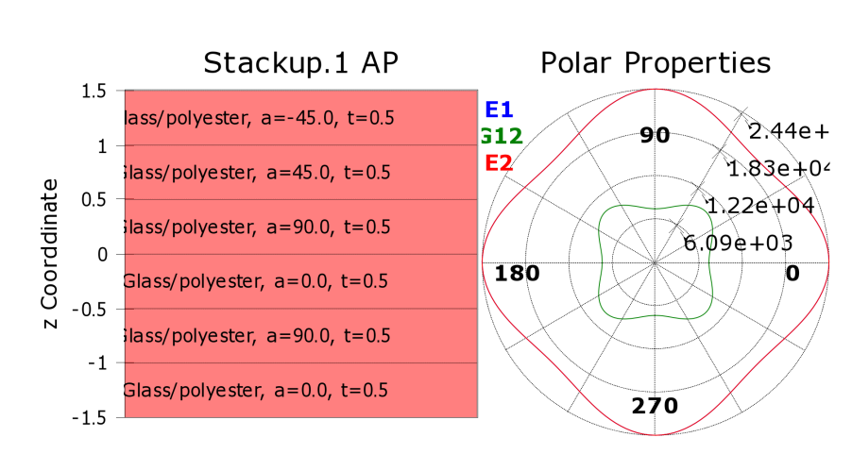

*Figure 3: E-glass stacking sequences and their directions, thickness and associated properties*

As mention before, each ply of the E-glass fibre has its own direction. This is visualized in Figure 4. This showed what it looks like that six layers of glass fibre piled together.

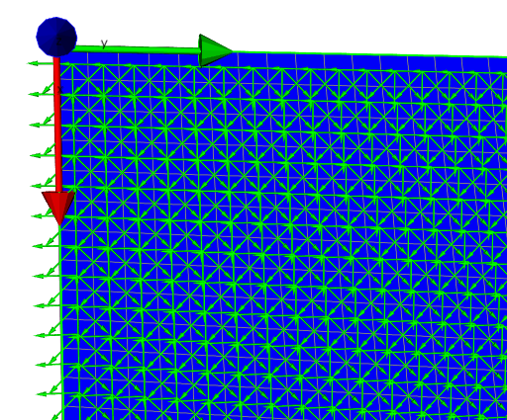

*Figure 4: Fabrics directions*

Six layers of PVC foam is added between the two E-glass face-sheets. Each ply has a thickness of 5 mm. The material alignment of the whole composite structure is illustrated in Figure 5. The thickness of E-glass fibre layers is too small comparing to the PVC foam. They are shown as thin lines in the upper and bottom of the figure.

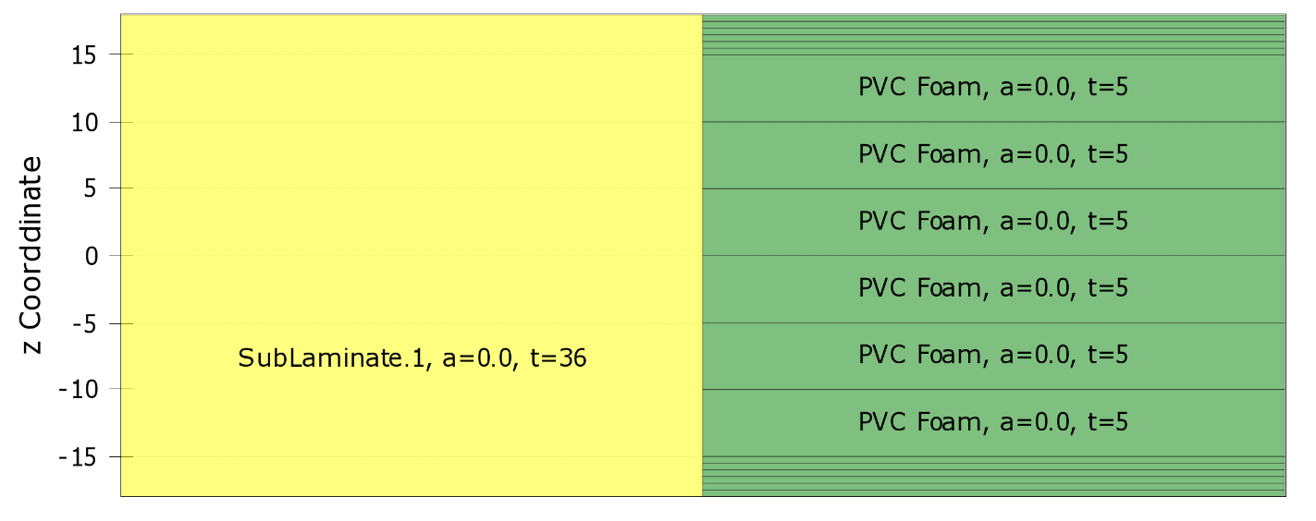

*Figure 5: Material Alignment of the Composite Structure*

When the materials and structures are set up, it is able to build the solid model. For some simple composite structures, shell elements are good enough to simulate the deformation and stress distribution. But for thick composites like this chosen experiment, the layered shell theory can cause significant errors in the obtained results. [9] In this case, solid models are required. The solid model is built according to the mesh definition and the material layers. It is illustrated in Figure 5 in the next chapter.

# 5. Mesh and Refinement

## 5.1 Mesh Method

A good mesh is the basic to ensure the quality of the simulation. The mesh in Z direction, hence the layers of materials were controlled by the ACP (pre) module, while the face sizing could still be modified by some mesh method. When coming to the setting of meshes for the geometry, there are a lot of options need to be chosen: structured or unstructured, quadrilaterals or triangles. Meshing method could have great influence on the accuracy of our results, so they need to be carefully decided.

In this project, structured mesh is chosen, as structured meshing method normally has better accuracy and takes less computational resource. When taking transient analyses and applying explicit dynamic module, the solving time could be very long due to its complexity. So computational resource saving is a critical consideration here.

The projectile ball is hard to set as structured mesh. It is not our main investigate target and its mesh has little influence on the result, so it is set with a coarse unstructured mesh.

In order to get a better mesh and develop more accurate result, smaller size mesh elements are allocated around the impact area. A mesh refinement procedure is carried out in the following part.

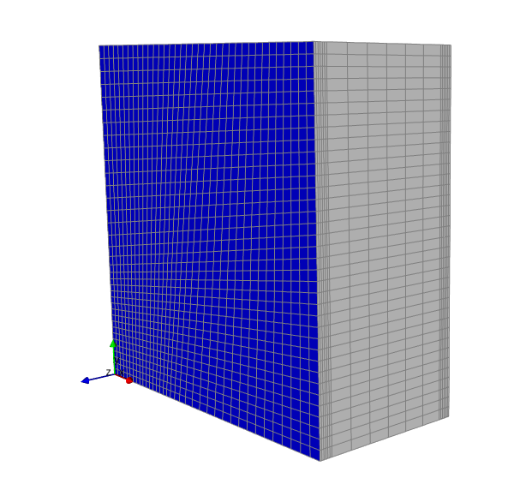

*Figure 6: Structured Mesh of the composite structure*

## 5.2 Mesh Refinement

The purpose of the experiment simulation is to develop a reliable model. The residual velocity is set to be the validation data. In consider of this, the residual velocity of the projectile is also used here as the mesh refinement indicator.

A certain initial inlet velocity of 400 m/s is taken, which is not far above the experimental projectile velocity. Projectile velocity is the inlet speed which is just absorbed by the composite board. This setting would give out an obvious residual velocity, which was investigated as the indicator to compare different meshes. Seen from Figure 7, it is clear that as the mesh element number increasing, the residual velocity converged to a certain value. More element would take much more calculation time, especially in the transient analyses case. A compromise has to be made between accuracy and time consuming.

The 8,814 element model is chosen in this project, as it relatively accurate and took a reasonable time (about 20 minutes) to solve one set of results.

*Figure 7: Mesh Convergence*

# 6. Results

Figure 8 shows the stress distribution after the impact of 300 m/s velocity. This figure is at the end time of 0.5 mms. As is shown in the figure, the projectile almost went through this composite board, but still remains in the back board. Looking into figure 6, it could be found that the velocity of the projectile dropped from the 300 m/s to 5 m/s. This means that 300 m/s could be taken as the ballistic limit.

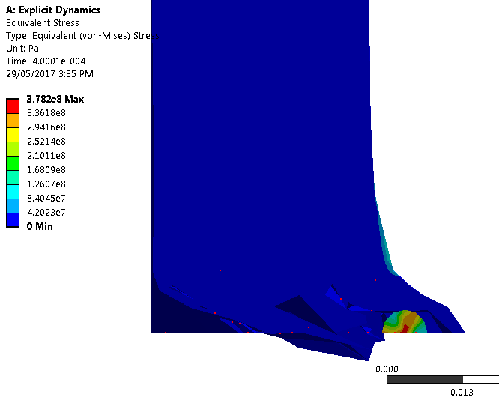

*Figure 8: Stress distribution*

The impact velocity was changed from 80 m/s to 600 m/s to find out its corresponding residual velocity in the experiment made by Shirley K. Gastillo. [1] This range was also investigated by our simulation model. The results are shown in Figure 10. It could be confirmed again that the ballistic limit is around 300 m/s. If the projectile has lower initial velocity than this, it could not go through this composite board and will stuck in the material. The purpose of this project is to design a light enough composite material board which has a high enough ballistic limit to withstand the debris shock during storms.

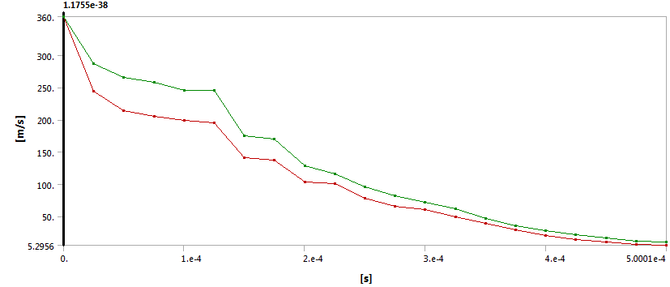

*Figure 9: Velocity of the Projectile through Time*

# 7. Validation

The validation process is to make sure that our simulation could represent reality. A direct method is to compare our simulation result with the experiment data. This comparison is illustrated in figure 6.

As could be seen, the simulation results fit quite well to the experiment data, especially in higher velocity margin. There is still some difference in the ballistic limit area. The simulation limit is about 360m/s as discussed in former part, while the experiment ballistic limit is about 320 m/s. The difference is about 12%. So we may need to take a safety factor larger than 1.2 to avoid this difference effect.

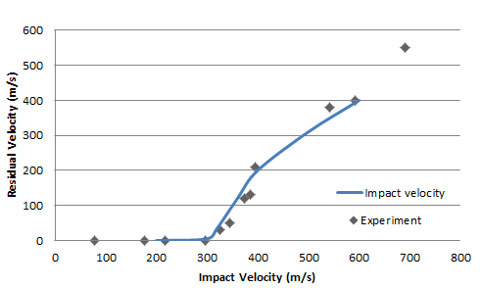

*Figure 10: Simulation Results Compare to Experiment Data*

# 8. Window protection board design

The whole process in the former part of this report is trying to build a reliable composite material model. Then the window protection board could be designed rely on this model.

The design process is similar to the former part. Firstly, a board model needs to be built according to the geometry of a window. Then make appropriate boundary conditions and initial conditions. Thirdly, it’s the meshing process and at last, solution and result discussion. A sensitive analysis of the core and front and back face-sheet is executed in order to find out the influence of different part on the protection performance. Base on the sensitive analysis, the final design of the composite window protection board could be obtained.

## 8.1 Model of Window Protection Board

A model of window protection composite material board is developed in this section. The dimension of this board is 2000*1000 mm2, and the thickness is set to be the same initially as the former model, which are two 3 mm face-sheets and a 30 mm core.

The boundary conditions are the same as the former model: fixed support on the four edges. This model is also symmetrised along the two centre plane. So symmetry boundary conditions also need to be applied. The geometry and boundary conditions of this model is shown in figure 7 bellow.

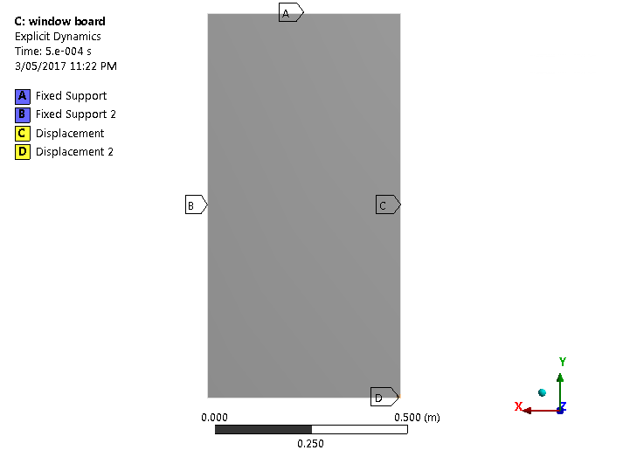

*Figure 7: Geometry and Boundary Conditions of the Protection Board Model*

## 8.2 Mesh and refinement

The meshing method is similar to the former model. Structured mesh is utilized to save computational resource and time consumption. The mesh of the projectile is set to be coarse. A spherical body size is allocated near the impact region to refine this area. One edge size is set on the two face-sheets thickness direction to make sure there are more than 4 layers on each sheet. The meshing result is shown below in figure 8.

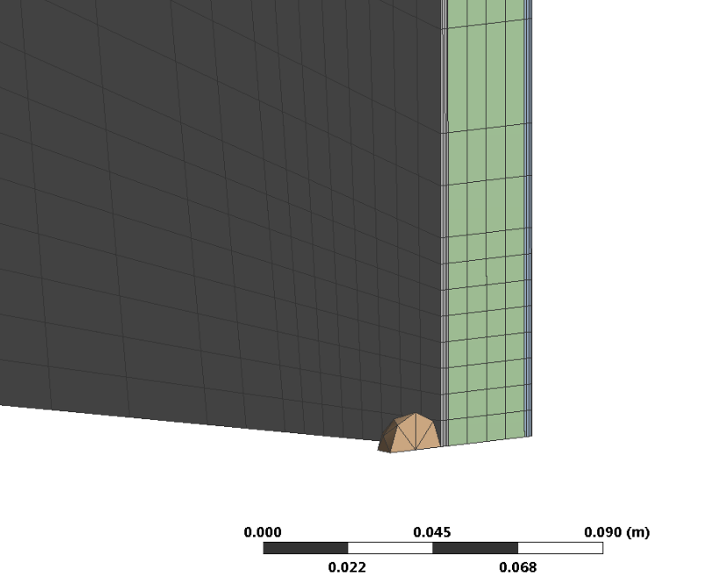

*Figure 8: Mesh of The Protection Board Model*

The residual velocity is also set as the mesh refinement indicator. A certain impact velocity is given, as the number of mesh element increase, the residual velocity converge at a certain value. The convergence process is show in figure 9.

*Figure 9: Mesh Convergence*

## 8.3 Sensitive analysis

The thickness of core and two face-sheet were decreased to investigate how much they would affect the protection performance, hence, the ballistic criteria.

Core thickness of the PVC foam is tested at first. It was reduced by 5 mm at a time, which is the thickness of one layer set in the ACP module. So it just need to reduce one layer of the core material in the construction pile. The influence of each layer is shown in Figure 10. It could be seen that

*Figure 10: Influence of PVC foam on the Protection Performance*

The E-glass/polyester woven laminate is much harder compare to the PVC Foam core. As shown in Figure 10, the influence of the PVC foam is limited. Even if the whole core is removed, the ballistic criteria velocity would not decrease much. This is also proved by experiment taken by Shirley K. Gastillo. [1] He compared the performance of the composite structure with two separated face-sheet. The simulation corresponded with his experiment result that the criteria decreased about 10%.

Then the influence of the front and back face-sheet is investigated. The results of the sensitivity analysis is illustrated in Figure 11 and Figure 12.

*Figure 10: Influence of the Front Face-sheet on the Protection Performance*

*Figure 11: Influence of the Back Face-sheet on the Protection Performance*

It could be known from the two figure above that

## 8.4 Results and Discussion

In this section, the minimum core thickness is calculated through another several times of simulation. This process started from the original core thickness of 30 mm and then decrease in each time. Until the projectile of 34 m/s could shoot through the board. This procedure is shown in the following figure. After we found the limit thickness, a safety factor of 1.2 is multiplied as discussed in the former part.

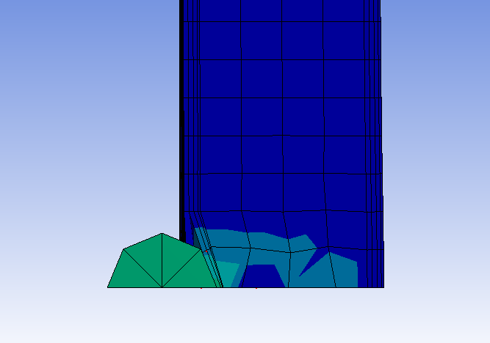

*Figure 10: Deformation for the Initial Model*

As is shown in figure 10, the projectile could not shoot through the initial model. So the thickness of the core material was decreased. The residual velocity is still taken as indicator, the plot is shown below in figure 11.

Seen from figure 11, the critical core thickness is around 10 mm. Multiply it with the safety factor of 1.2, gives the final core thickness of our design is 12 mm.

*Figure 11: Core Thickness Design*

# 9. Conclusion

The composite material window protection board is designed out now, it has two layers of 3 mm face-sheets, and one layer of 12 mm PVC foam core. This board is available to provide protection in cyclones according to the definition of Design guidelines for Queensland public cyclone shelters [5]

This board model is reliable as it was validated through comparison with experiment data. Although there is no data to validate our final model. This model could be modified in dimensions to design other kind of window protector.

Due to a factor of time, only core thickness variation is simulated in this project. The face-sheet thickness and other materials should also be checked to finish this design work.

# Reference

[1] Shirley K. Gastillo, Brenda L. Buitrago, Behavior of sandwich structures and spaced plates subjected to high-velocity impacts.2011

[2] Ivanez Santiuste, E. Barbero, Numerical modelling of foam-cored sandwich plates under high-velocity impact, 2011

[3] Rasoul Nasirzadeh, Study of foam density variations in composite sandwich panels under high velocity impact loading, 2014

[4] Md. Ansari, Behaviour of GFRP composite plate under ballistic impact: experimental and FE analyses, 2016

[5] Standards Australia, Standards New Zealand, AS 1170.2:2011 Structural design actions Part 2: Wind actions, 2011

[6] Mulins consulting Pty Ltd, Design guidelines for Queensland public cyclone shelters, 2006

[7] Ulrich Frye, Simulated wind driven debris impact testing of crimsafe debris screen, 2010

[8] Krikkajon Tanadrob, Composite Material Modeling under Drop Weight Impact test Using Finite Element Analysis*, Materials Science Forum ISSN: 1662-9572, Vol. 889, pp 3-8*, 2016

[9] ANSYS Composite PrepPost User’s Guide, ANSYS Inc. release 15.0 November 2013